X HOME SENSOR PCB

- PARTS:

QUANTITY: PART #: NOMENCLATURE: LENGTH:

1 PER MACHINE 09540- PCB, BLANK, X-Y LIMIT SENSOR N/A

1 PER MACHINE 18457- SENSOR, PHOTOLOGI N/A

1 PER MACHINE 15332- RESISTOR, 220Ω, ¼ W N/A

1 PER MACHINE 17547-4 HEADER, 4-PIN, METHODE, RT. ANGLE N/A

- ASSEMBLY:

- INSERT AND SOLDER THE RESISTOR INTO PLACE WITH THE RED STRIPES TOWARDS THE HEADER LOCATION, ACCORDING TO DIAGRAM 1.

- INSERT AND SOLDER THE HEADER INTO PLACE, ACCORDING TO DIAGRAM 1.

- INSERT AND SOLDER THE SENSOR WITH THE WRITTEN-SIDE TOWARDS THE RESISTOR, ACCORDING TO DIAGRAM 1.

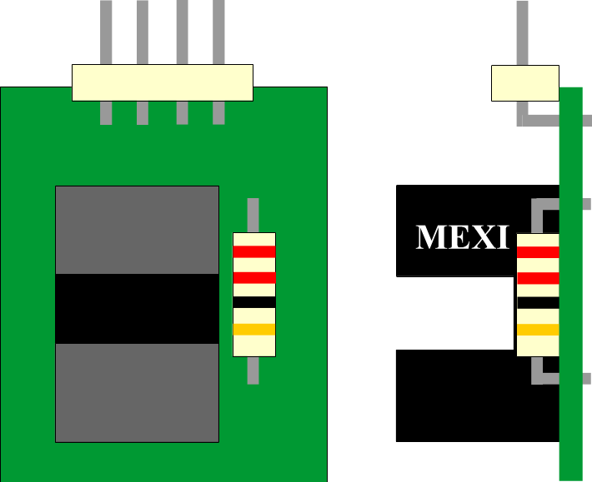

DIAGRAM 1

